**EXPERIMENT 02**

**AIM:** Creation of Scenarios and story board for application.

**EXPLANATION:**

What is a User Scenario?

User scenario is a detailed description of what users do with the product and more importantly why they do it. It is longer and more informative than a user story, but still you have to keep it to the point and include only information that is highly relevant to the user’s experience with the product. User scenarios outline the motivation and the main goal of the user for visiting your website or using your product. It is best to keep the user scenarios as close to reality as possible, using the expressions and wording a typical user would speak. This way you can adjust your CTAs and other microscopy accordingly. A user scenario simply describes a basic story of an action or goal that a user wants to accomplish. It might be how Kevin needs to buy a CD online for delivery today for his friend’s birthday, for example. Of course, scenarios can be much more detailed too the idea is to work out the: who, what, when, where, why and how of the user’s scenario.

**OUTPUT:**

**USE CASE DIAGRAM:**

Any complex system is best understood by making some kind of diagrams or pictures. These diagrams have a better impact on our understanding. If we look around, we will realize that the diagrams are not a new concept but it is used widely in different forms in different industries.We prepare UML diagrams to understand the system in a better and simple way. A single diagram is not enough to cover all the aspects of the system. UML defines various kinds of diagrams to cover most of the aspects of a system.

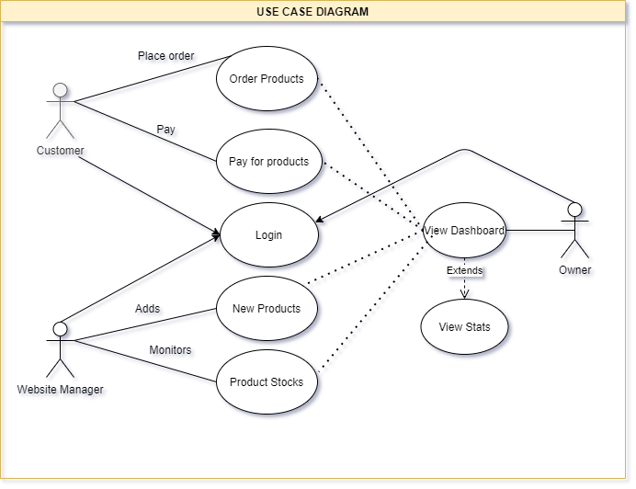

**SCENARIO MAP:**

Scenario mapping is the process of outlining all the steps a user will take to complete a task. It generally includes notes about what users are thinking and feeling at each step. It can also include comments or information you feel is important for each step, questions or assumptions you have, and good ideas or suggestions that come up as you go through this exercise. scenario maps are not intended to represent every possible interaction with a system or product but rather to capture the most important interactions. If you try to cover everything, particularly with a complex product, you’re going to find that future iterations of the scenario maps become ever more convoluted (as one change will impact a bunch of other scenarios) so it’s best to keep things quite high-level.

User Name: Seema Agrawal – Software Engineer

Buying a lipstick online.

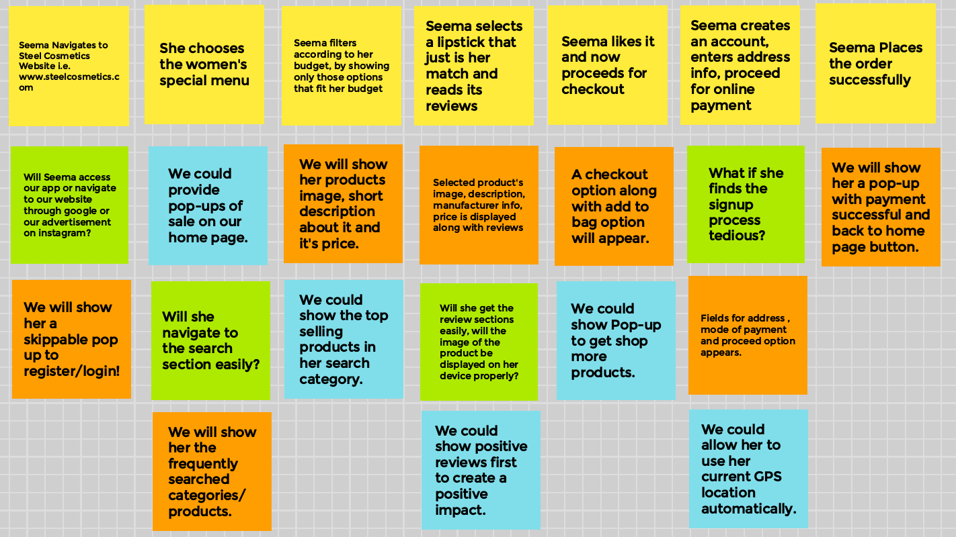

Steps Comments Ideas Questions

**USER STORY BOARD:**

Storyboards are illustrations that represent shots that ultimately represent a story. Basically, it’s a sequential art, where images are arrayed together to visualise the story. This method came from the motion picture production. The Walt Disney studio is credited with popularising storyboards, using sketches of frames since the 1920s. Storyboards allow them to build the world of the film before they actually build it.

